1. Clean the data by filling the missing data in some of the columns.
There are not any missing values on the table.

2. Find out the minimum, maximum, and average (mean) LotArea.
Formula | Answer
=MIN(C2:C1461) | 1300
=MAX(C2:C1461) | 215245
=AVERAGE(C2:C1461) | 10516.83

3. Plot the correlation between the columns:
- TotalBsmtSF and GrLivArea
- LotArea and SalePrice

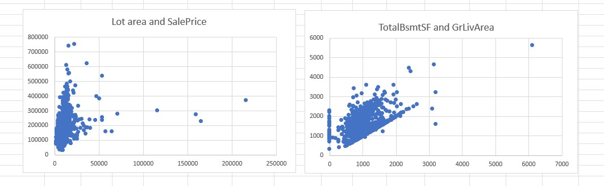

4. Create scatter plots for:
- BsmtFinSF1, BsmtFinSF2, BsmtUnfSF

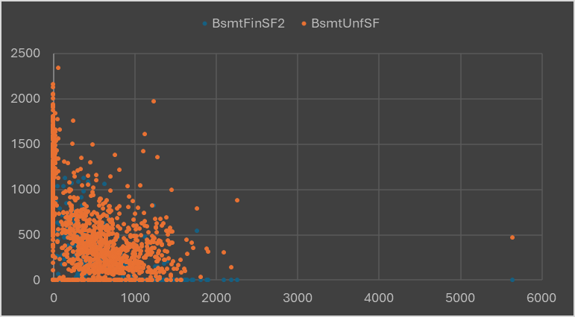

- 1stFlrSF, 2ndFlrSF

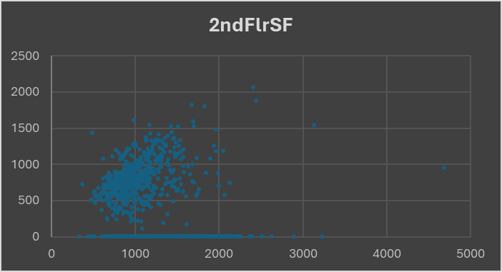
- TotalBsmt and GrLivArea

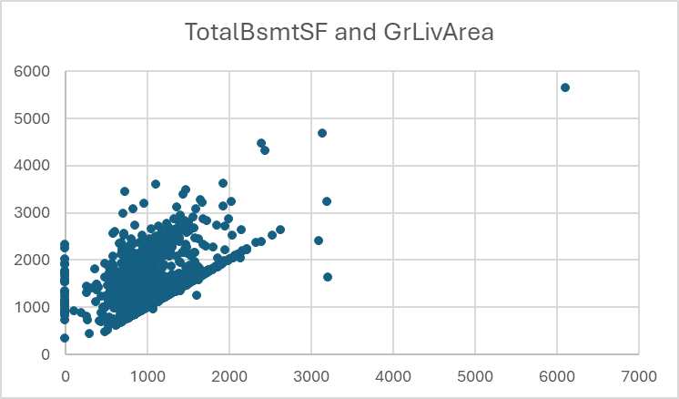

- GrLivArea and GarageArea

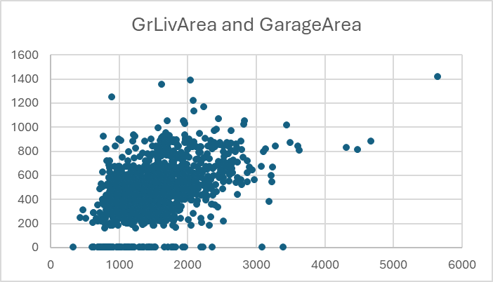

5. Create a regression model based on the given data.

Regression on the basis of LotArea and Sale Price
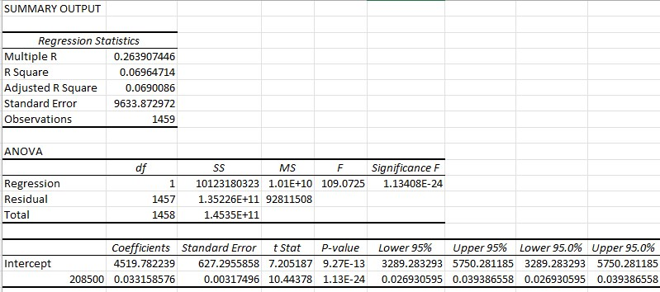

6. Get the R², adjusted R², and coefficient values.

